After opening second.cc (Add NetAnim Module):
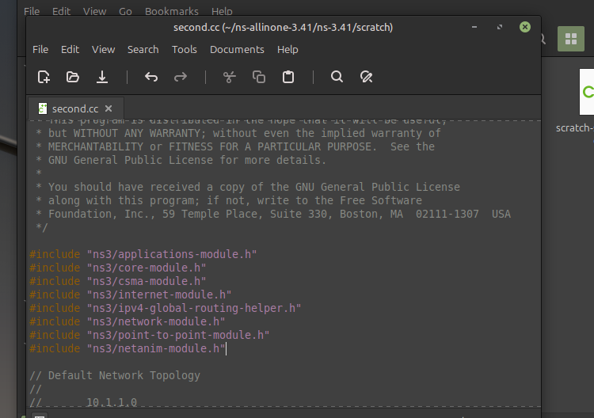
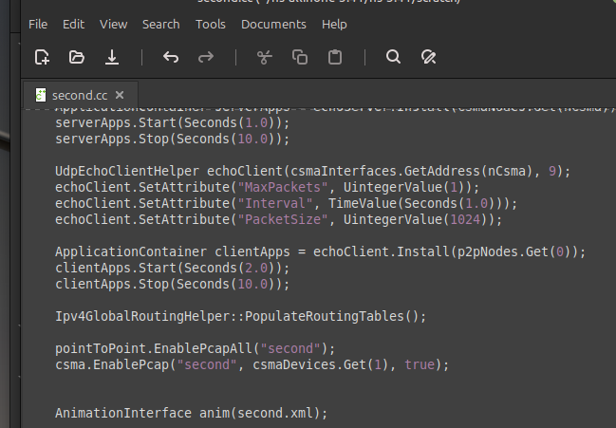

Animator grid and fileopen present:
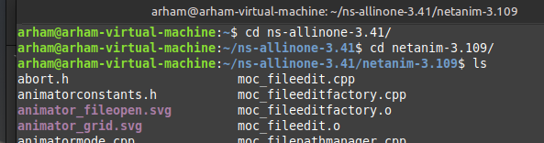
Since ns-3.36, ns-3 has replaced Waf with CMake.
To Generate Second.xml file:
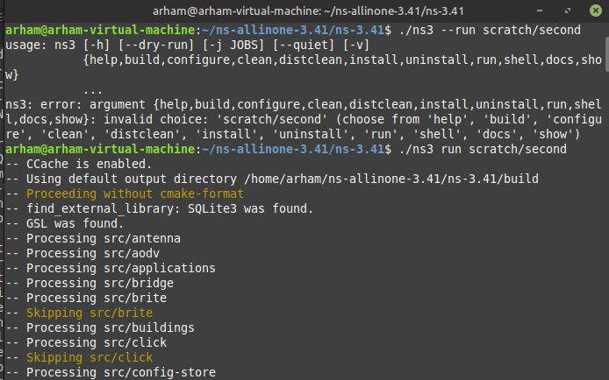
Visualizing Second.xml file on NetAnim:
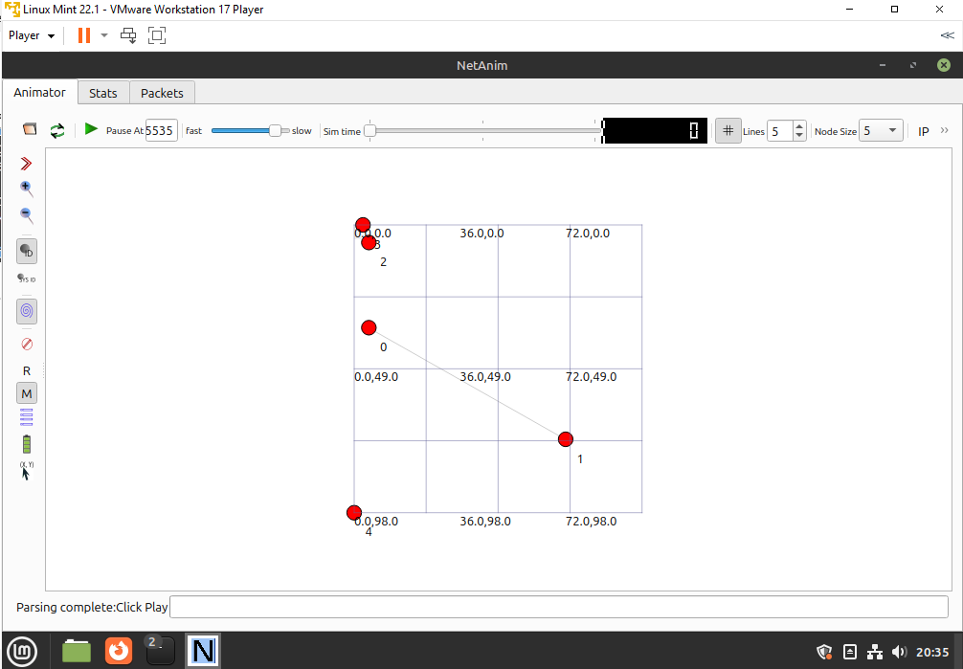
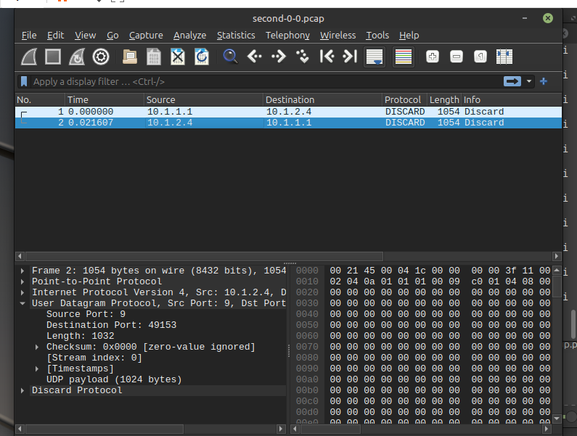

This was for UDP.
TCP Congestion Task
Seventh.cc code:
#include <fstream>
#include "ns3/core-module.h"
#include "ns3/network-module.h"
#include "ns3/internet-module.h"
#include "ns3/point-to-point-module.h"
#include "ns3/applications-module.h"
#include "ns3/stats-module.h"

using namespace ns3;

NS_LOG_COMPONENT_DEFINE ("SeventhScriptExample");

// ===========================================================================
//
// node 0 node 1
// +----------------+ +----------------+
// | ns-3 TCP | | ns-3 TCP |
// +----------------+ +----------------+
// | 10.1.1.1 | | 10.1.1.2 |
// +----------------+ +----------------+
// | point-to-point | | point-to-point |
// +----------------+ +----------------+
// | |
// +---------------------+
// 5 Mbps, 2 ms
//
//
// We want to look at changes in the ns-3 TCP congestion window. We need
// to crank up a flow and hook the CongestionWindow attribute on the socket
// of the sender. Normally one would use an on-off application to generate a
// flow, but this has a couple of problems. First, the socket of the on-off
// application is not created until Application Start time, so we wouldn't be
// able to hook the socket (now) at configuration time. Second, even if we
// could arrange a call after start time, the socket is not public so we
// couldn't get at it.
//
// So, we can cook up a simple version of the on-off application that does what
// we want. On the plus side we don't need all of the complexity of the on-off
// application. On the minus side, we don't have a helper, so we have to get
// a little more involved in the details, but this is trivial.
//
// So first, we create a socket and do the trace connect on it; then we pass
// this socket into the constructor of our simple application which we then
// install in the source node.
// ===========================================================================
//
class MyApp : public Application
{
public:
MyApp ();
virtual ~MyApp ();

void Setup (Ptr<Socket> socket, Address address, uint32_t packetSize, uint32_t nPackets, DataRate dataRate);

private:
virtual void StartApplication (void);
virtual void StopApplication (void);

void ScheduleTx (void);
void SendPacket (void);

Ptr<Socket> m_socket;
Address m_peer;
uint32_t m_packetSize;
uint32_t m_nPackets;
DataRate m_dataRate;
EventId m_sendEvent;
bool m_running;
uint32_t m_packetsSent;
};

MyApp::MyApp ()
: m_socket (0),
m_peer (),
m_packetSize (0),
m_nPackets (0),
m_dataRate (0),
m_sendEvent (),
m_running (false),
m_packetsSent (0)
{
}

MyApp::~MyApp ()
{
m_socket = 0;
}

void
MyApp::Setup (Ptr<Socket> socket, Address address, uint32_t packetSize, uint32_t nPackets, DataRate dataRate)
{
m_socket = socket;
m_peer = address;
m_packetSize = packetSize;
m_nPackets = nPackets;
m_dataRate = dataRate;
}

void
MyApp::StartApplication (void)
{
m_running = true;
m_packetsSent = 0;
if (InetSocketAddress::IsMatchingType (m_peer))
{
m_socket->Bind ();
}
else
{
m_socket->Bind6 ();
}
m_socket->Connect (m_peer);
SendPacket ();
}

void
MyApp::StopApplication (void)
{
m_running = false;

if (m_sendEvent.IsRunning ())
{
Simulator::Cancel (m_sendEvent);
}

if (m_socket)
{
m_socket->Close ();
}
}

void
MyApp::SendPacket (void)
{
Ptr<Packet> packet = Create<Packet> (m_packetSize);
m_socket->Send (packet);

if (++m_packetsSent < m_nPackets)
{
ScheduleTx ();
}
}

void
MyApp::ScheduleTx (void)
{
if (m_running)
{
Time tNext (Seconds (m_packetSize * 8 / static_cast<double> (m_dataRate.GetBitRate ())));
m_sendEvent = Simulator::Schedule (tNext, &MyApp::SendPacket, this);
}
}

static void
CwndChange (Ptr<OutputStreamWrapper> stream, uint32_t oldCwnd, uint32_t newCwnd)
{
NS_LOG_UNCOND (Simulator::Now ().GetSeconds () << "\t" << newCwnd);
*stream->GetStream () << Simulator::Now ().GetSeconds () << "\t" << oldCwnd << "\t" << newCwnd << std::endl;
}

static void
RxDrop (Ptr<PcapFileWrapper> file, Ptr<const Packet> p)
{
NS_LOG_UNCOND ("RxDrop at " << Simulator::Now ().GetSeconds ());
file->Write (Simulator::Now (), p);
}

int
main (int argc, char *argv[])
{
bool useV6 = false;

CommandLine cmd;
cmd.AddValue ("useIpv6", "Use Ipv6", useV6);
cmd.Parse (argc, argv);

NodeContainer nodes;
nodes.Create (2);

PointToPointHelper pointToPoint;
pointToPoint.SetDeviceAttribute ("DataRate", StringValue ("5Mbps"));
pointToPoint.SetChannelAttribute ("Delay", StringValue ("2ms"));

NetDeviceContainer devices;
devices = pointToPoint.Install (nodes);

Ptr<RateErrorModel> em = CreateObject<RateErrorModel> ();
em->SetAttribute ("ErrorRate", DoubleValue (0.00001));
devices.Get (1)->SetAttribute ("ReceiveErrorModel", PointerValue (em));

InternetStackHelper stack;
stack.Install (nodes);

uint16_t sinkPort = 8080;
Address sinkAddress;
Address anyAddress;
std::string probeName;
std::string probeTrace;
if (useV6 == false)
{
Ipv4AddressHelper address;
address.SetBase ("10.1.1.0", "255.255.255.0");
Ipv4InterfaceContainer interfaces = address.Assign (devices);
sinkAddress = InetSocketAddress (interfaces.GetAddress (1), sinkPort);
anyAddress = InetSocketAddress (Ipv4Address::GetAny (), sinkPort);
probeName = "ns3::Ipv4PacketProbe";
probeTrace = "/NodeList/*/$ns3::Ipv4L3Protocol/Tx";
}
else
{
Ipv6AddressHelper address;
address.SetBase ("2001:0000:f00d:cafe::", Ipv6Prefix (64));
Ipv6InterfaceContainer interfaces = address.Assign (devices);
sinkAddress = Inet6SocketAddress (interfaces.GetAddress (1,1), sinkPort);
anyAddress = Inet6SocketAddress (Ipv6Address::GetAny (), sinkPort);
probeName = "ns3::Ipv6PacketProbe";
probeTrace = "/NodeList/*/$ns3::Ipv6L3Protocol/Tx";
}

PacketSinkHelper packetSinkHelper ("ns3::TcpSocketFactory", anyAddress);
ApplicationContainer sinkApps = packetSinkHelper.Install (nodes.Get (1));
sinkApps.Start (Seconds (0.));
sinkApps.Stop (Seconds (20.));

Ptr<Socket> ns3TcpSocket = Socket::CreateSocket (nodes.Get (0), TcpSocketFactory::GetTypeId ());

Ptr<MyApp> app = CreateObject<MyApp> ();
app->Setup (ns3TcpSocket, sinkAddress, 1040, 1000, DataRate ("1Mbps"));
nodes.Get (0)->AddApplication (app);
app->SetStartTime (Seconds (1.));
app->SetStopTime (Seconds (20.));

AsciiTraceHelper asciiTraceHelper;
Ptr<OutputStreamWrapper> stream = asciiTraceHelper.CreateFileStream ("seventh.cwnd");
ns3TcpSocket->TraceConnectWithoutContext ("CongestionWindow", MakeBoundCallback (&CwndChange, stream));

PcapHelper pcapHelper;
Ptr<PcapFileWrapper> file = pcapHelper.CreateFile ("seventh.pcap", std::ios::out, PcapHelper::DLT_PPP);
devices.Get (1)->TraceConnectWithoutContext ("PhyRxDrop", MakeBoundCallback (&RxDrop, file));

// Use GnuplotHelper to plot the packet byte count over time
GnuplotHelper plotHelper;

// Configure the plot. The first argument is the file name prefix
// for the output files generated. The second, third, and fourth
// arguments are, respectively, the plot title, x-axis, and y-axis labels
plotHelper.ConfigurePlot ("seventh-packet-byte-count",
"Packet Byte Count vs. Time",
"Time (Seconds)",
"Packet Byte Count");

// Specify the probe type, probe path (in configuration namespace), and
// probe output trace source ("OutputBytes") to plot. The fourth argument
// specifies the name of the data series label on the plot. The last
// argument formats the plot by specifying where the key should be placed.
plotHelper.PlotProbe (probeName,
probeTrace,
"OutputBytes",
"Packet Byte Count",
GnuplotAggregator::KEY_BELOW);

// Use FileHelper to write out the packet byte count over time
FileHelper fileHelper;

// Configure the file to be written, and the formatting of output data.
fileHelper.ConfigureFile ("seventh-packet-byte-count",
FileAggregator::FORMATTED);

// Set the labels for this formatted output file.
fileHelper.Set2dFormat ("Time (Seconds) = %.3e\tPacket Byte Count = %.0f");

// Specify the probe type, probe path (in configuration namespace), and
// probe output trace source ("OutputBytes") to write.
fileHelper.WriteProbe (probeName,
probeTrace,
"OutputBytes");

Simulator::Stop (Seconds (20));
Simulator::Run ();
Simulator::Destroy ();

return 0;
}
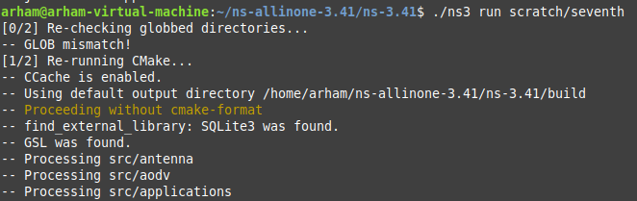
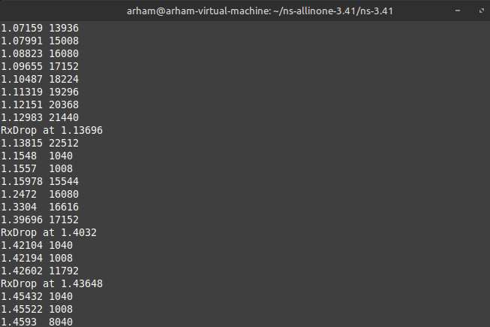
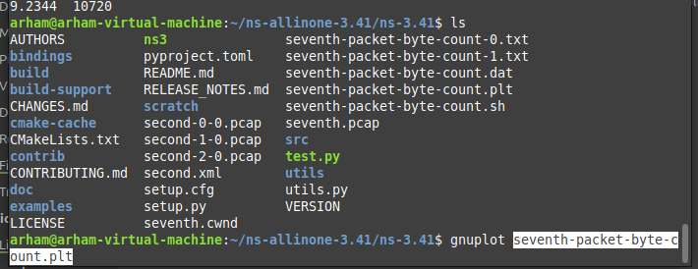
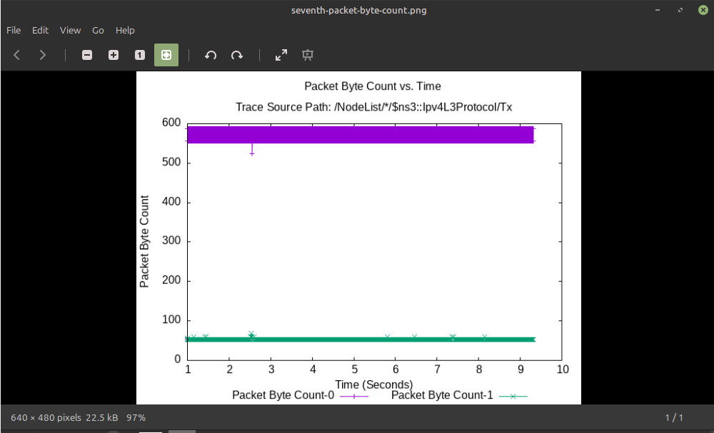
Congestion Window:
3 Values:
Timestamp OldCongestionWindow NewCongestionWindow

For Every packet, New Congestion Value will become the old Congestion Value.
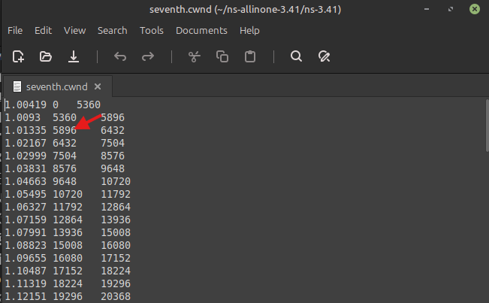
Congestion Avoidance (Once congestion reaches certain value, the new value is bringed down):
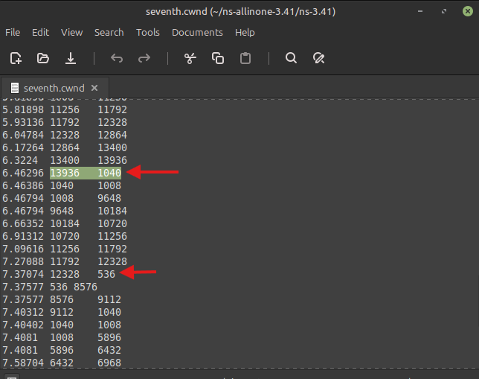
Now Plotting congestion Window:
